Model Results
Sr. No | Name | Accuracy | Precision | Recall | F1_score | Sensitivity | Specificity
1 | AlexNet | 99.37% | 99.40% | 99.37% | 99.38% | 99.37% | 99.40%
2 | ResNet-50 | 98.63% | 98.72% | 98.58% | 98.64% | 98.58% | 98.72%
3 | Inception-V3 | 97.88% | 97.96% | 97.43% | 97.64% | 97.43% | 97.96%
4 | DenseNet-201 | 99.54% | 99.51% | 99.59% | 99.54% | 99.59% | 99.51%

AlexNet Confusion Matrix
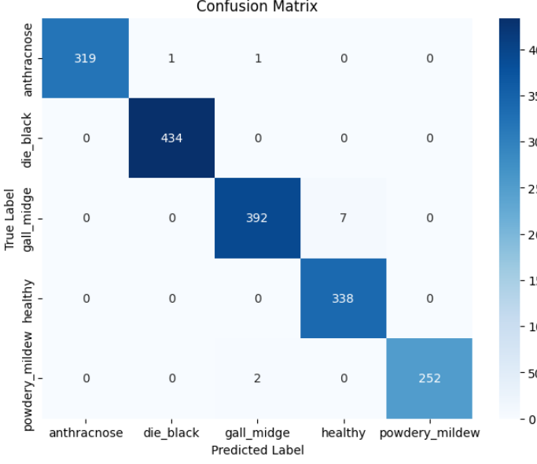
ResNet-50 Confusion Matrix
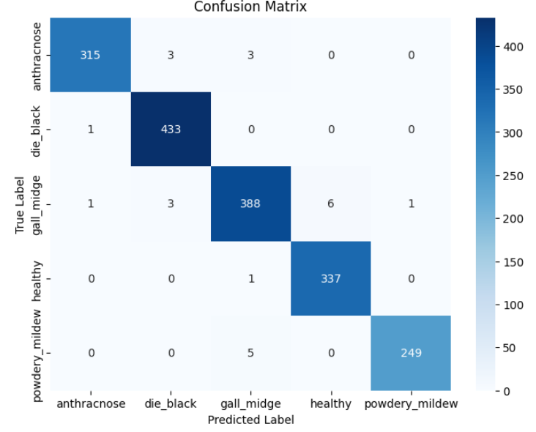
InceptionV3 Confusion Matrix
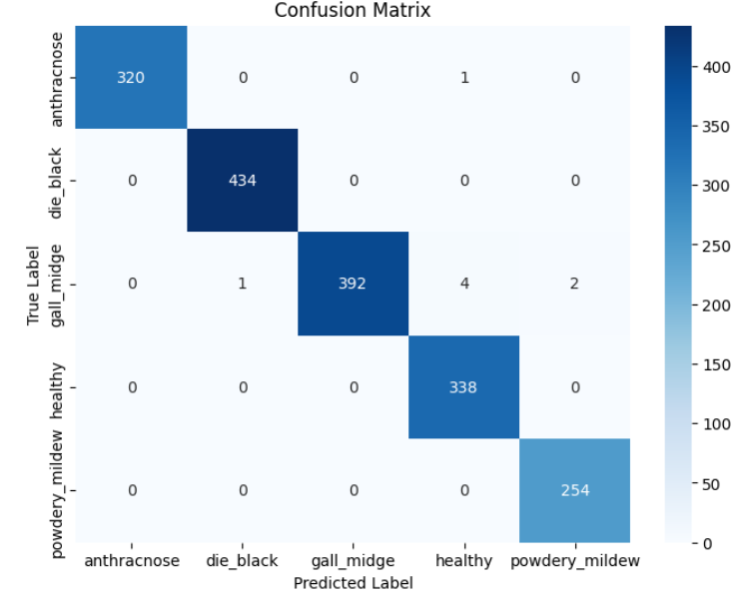

DenseNet-201 Confusion Matrix
